**IPT101**

**High Concept GDD**

**Members:**

1. **Haries Carlo M. Cos**
2. **Marlon A. Lin**
3. **Kendrick Christian Pinlac**

**Contents:**

1. **Logo:** The logo that also make our game “Hexoccupation Onslaught: Forgotten Citadel (HOFC)”

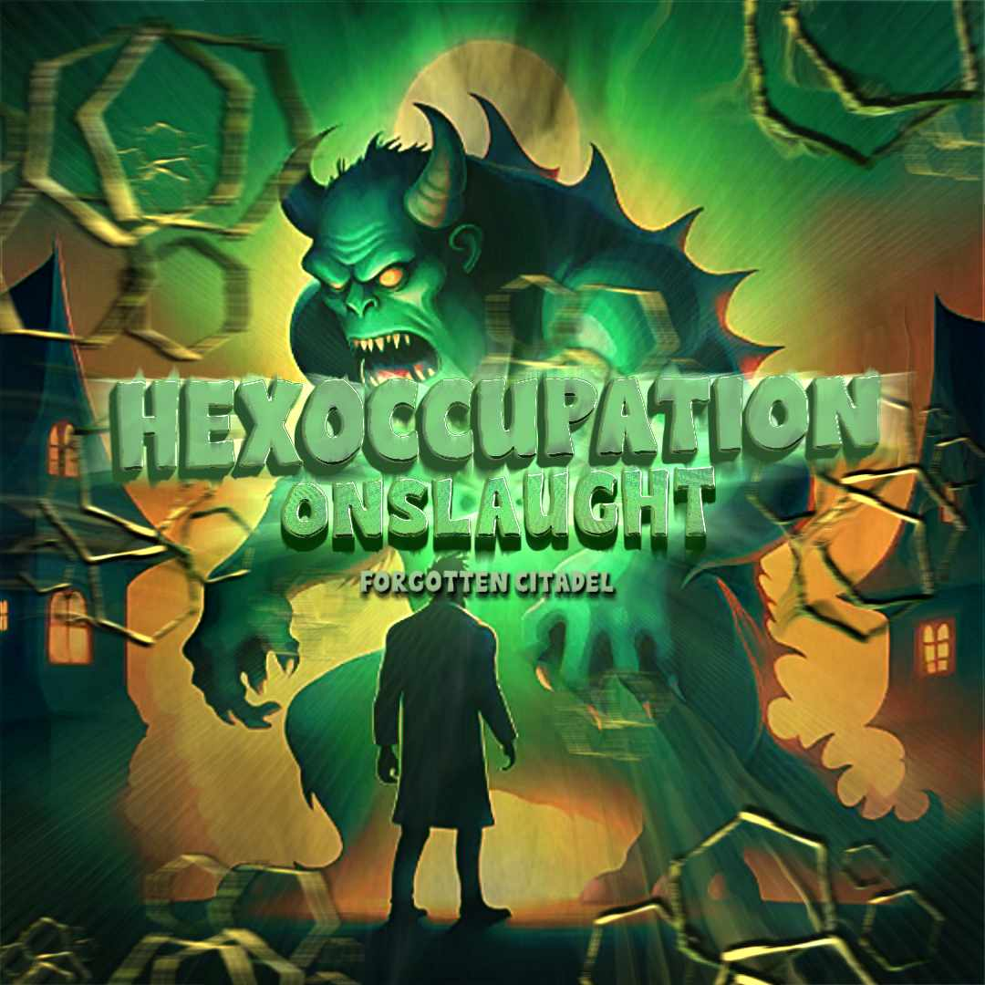

multiple elements in the logo. Hexagons, a key design component, most likely reflect the game's complex paths and strategic terrain. They represent the game board, implying that players would move around and strategize inside a hexagon area, highlighting the significance of careful preparation and movement. A man icon at the logo's base represents numerous occupations such as physicians, police officers, and teachers, many others. Its position at the bottom emphasizes vulnerability and challenge, implying that people from various careers would be prey or targets in the game. This arrangement offers a high-stakes and exciting game experience in which players must protect or escape these professional characters against the monsters.

The horrible monster in the logo assumes the role of a hunter, including elements of survival and competition. To dodge or combat this threatening opponent, players might have to take on other professions or jobs, such as physicians, police officers,teacher and more, adding an element of strategy and flexibility to the gameplay.

"Hexoccupation Onslaught: Forgotten Citadel," the game's name, deepens the story. "Hexoccupation" refers to the hexagonal layout of the game board, where players must navigate a sophisticated worker infrastructure while moving in six different directions. While "Forgotten Citadel" provides a captivating setting for the game's narrative and alluded to as holding important challenges or secrets for players to discover, "Onslaught" suggests intense monster battles. Overall, this logo creates the mood for an action-packed, strategic gaming experience where players control or protect real-world professionals in a perilous and complicated setting.

1. **Game Title:** Hexoccupation Onslaught: Forgotten Citadel
2. **Elevator Pitch:** Hexoccupation Onslaught: Forgotten Citadel is a Monsters vs. Workers strategic turn-based board game for 4-8 players. Monsters aim to convert workers within 20 turns, or risk workers gaining power to eliminate monsters. Special cards provide advantages, and endgame effects create thrilling finishes.
3. **Target Audience:** “Hexoccupation Onslaught: Forgotten Citadel”

is designed for casual player, board game enjoyer and individuals aged 12 years old and above. The multiple map scenarios in this game can be customized by the players for each playtime, they can maximize their game experience by collecting money to exchange for extra cards such as “end-game cards” to survive until 20 turns and become a soldier that can now fought back against monsters. “Hexoccupation Onslaught: Forgotten Citadel” enhance your strategic decision-making, fellowship and creativity.

1. **Player Interaction:** Unilateral Competition - “Hexoccupation Onslaught: Forgotten Citadel (HOFC)” is a type of game that consist of 8 players maximum (3 Monster and 5 Workers) with end-game bonuses victory type to make our players think wiser and be creative on the combination of cards. In this game, players take part in a variety of different map settings that they can alter for each gameplay with the challenges to survive on monsters.
2. **Design Pillar:** “Hexoccupation Onslaught: Forgotten Citadel (HOFC)” design pillar are gameboard customizable wherein player can customized the map each playtime that will avoid the repetitive scenario. Number of monsters depends on the size of players if total of 8 = 3 monsters, 5-7 players = 2 monsters, 4 players = 1 monster. Spell can active on turn and instantly also both can be used at the same time. In this game, strategic decision-making is one of the skill requirements for this game as player need to survive until 20 turns to become a soldier, they can use the resources such as cards and money to take advantage against the monsters.
3. **Inspiration:** The “Hexoccupation Onslaught: Forgotten Citadel (HOFC)” inspired by *Seven Seas Deluxe* and *Pac-Man*, the turn-based game of *Seven Seas Deluxe* and the whirlpool of it that is now portal in our game while successfully survived until 20 turns and becomes a soldier that can fought back against monster is similar to *Pac-Man* when he eats the blinking pellets, pacman can now eat ghosts without losing a single life.
4. **Game Loops:**

* **Infect/Convert:** Monsters can turn or convert workers into a monster when they are killed.
* **Can gain 2 monster spell cards per 5 turns:** Every 5 turns, all the monsters can receive 2 monster cards.
* **Portal:** Monsters can also use portals.
* **Earn Money:** Monsters can also gain money by stepping in a money tile.
* **Spawn:** Monsters can only spawn in Catacombs.
* **Spell:** Monsters can cast and buy spells.
* **Earn Extra Money:** When workers are on their own designated area, they can roll 2 dice at the same time to earn extra money. They can also gain money on the other infrastructure but only 1 die can roll.
* **Safehouse:** Workers can go to safehouses to avoid from getting attacked by a monster.
* **Portal:** Workers can use portals.